- Use SQLMap to check the SQL injection vulnerability of http://testphp.vulnweb.com/.

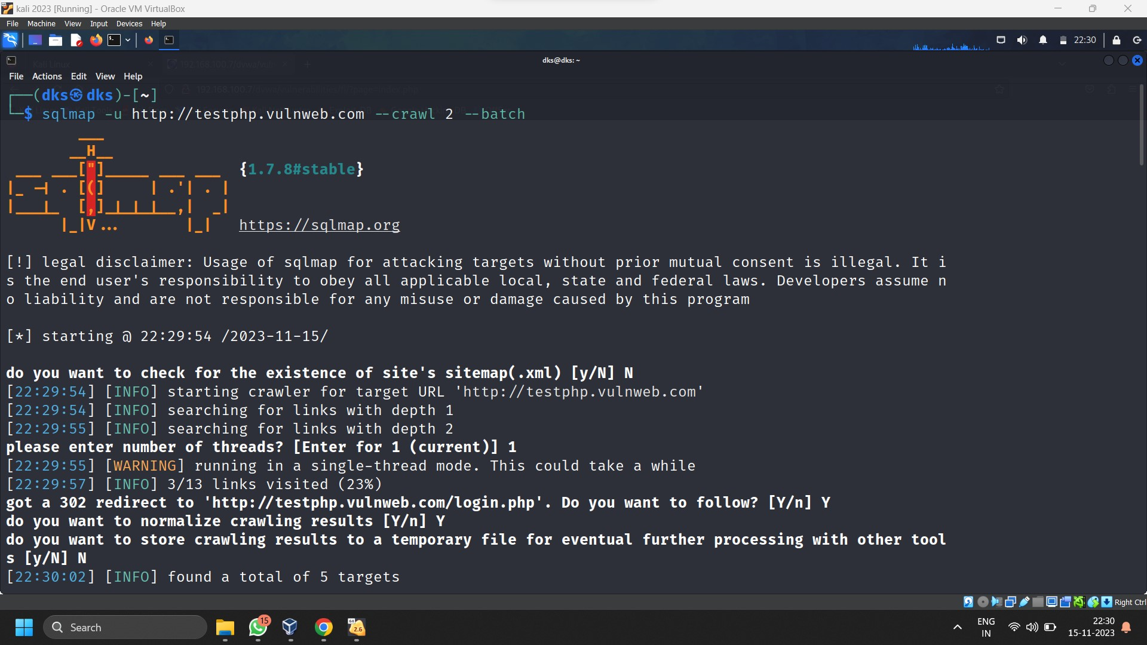

- Use SQLMap to check the SQL injection vulnerability of your OWASP Server.

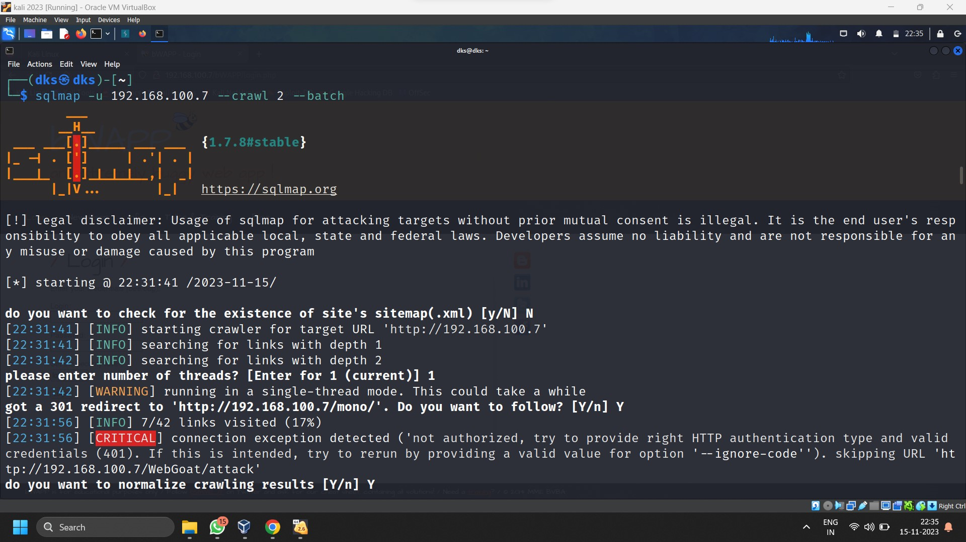

- Use Burp Suite to practice different attack types with OWASP bWAPP application

